How to find your digital stakeholders - consultation

Know who your stakeholders are

Your stakeholders will not change because the word ‘digital’ has been dropped in front. What will change is the method through which the signposting, consultation or discussion takes place, and potentially those involved. In a space where increasing engagement is the aim, digital offers an opportunity to expand the reach of government and reach those parts other engagement methods may not reach. On the flip side, those who are happy to engage offline, may not be familiar or comfortable with engaging online. Therefore, care is needed to ensure equity of access on both sides to discussions or consultations.

Drawing out a stakeholder map at this stage may be useful - you can start to annotate later with the mix of offline and online preferences where appropriate.

Work out what you want to achieve

Do you want to signpost stakeholders to a consultation, to get them involved in a discussion online that everyone can access or to get them to sign up to come to an offline round table? Do you want to reach groups of people who are difficult to engage, or who don’t at all? Or do you want to talk to the same people but in a space where those conversations are visible in order to achieve transparency in your process?

Where you communicate and how will depend on these objectives.

Playing digital smartly

This document does not intend to go into the detailed demographics of assorted channels. It is assumed either some knowledge of this is held, or is available within your organisations. Instead it focuses on finding groups of people within those spaces.

Twitter

Search

You will already know the names of the key stakeholder groups that you engage with, and chances are they will already be on Twitter, allowing you another chance to access their members, sometimes directly. If you wished to engage with Local Government, the Local Government Information Unit would probably be on your radar. Go to http://search.twitter.com (you will need to be logged in to get value from this). Enter LGIU (how they are commonly known) into the ‘contains all these words’ search box. Click search. The top result returned will be @lgiu. However, you will need to go deeper than this.

Something to bear in mind with this search and all those following is that if, as is the case with GDS, your abbreviated organisation name is also in common use in French or Spanish, you may want to use the location option or language option on Twitter search to restrict the search returns.

Finding yourself

One of the easiest ways to find where the conversations are happening on Twitter is to do keyword searches for your own organisation or Department name. Not everyone discussing your policies will @ mention you, either because they don’t know you’re in the conversation yet, or you actually aren’t in the conversation yet. Go to http://search.twitter.com (you will need a Twitter account in order to get the best from this tool) and enter the name of your organisation or Department in the ‘All of these words’ box. Below is the result for Cabinet Office.

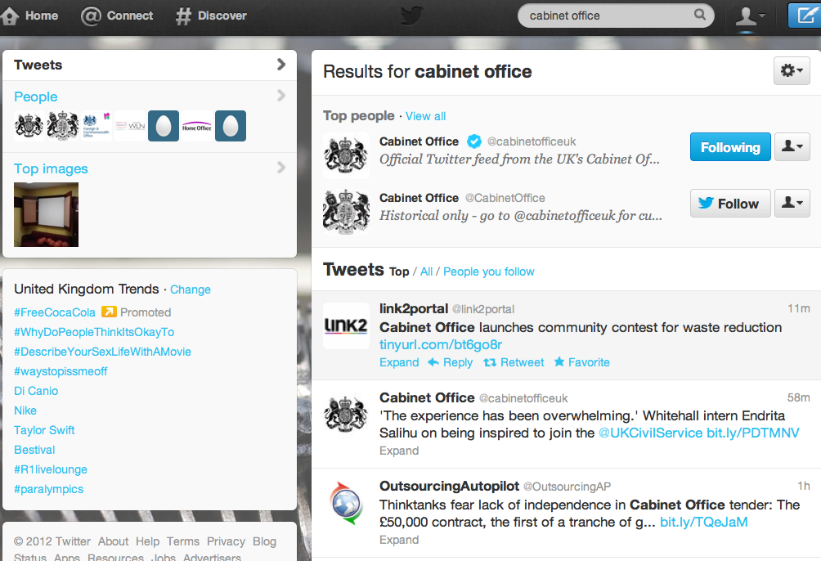

As this illustrates, the first 2 tweets found would not appear in the Cabinet Office’s mentions and the 2nd one is from the Cabinet Office itself. It may be that these two Twitter accounts (@link2portal and @outsourcingap) have low reach or are not stakeholders but this basic search is a key tool.

In addition to this form of searching, you can also do keyword searches as well as location restricted searches. For example if you were the Environment Agency you might want to find those discussing flooding within a 20km radius of the place affected, rather than getting bogged down with discussions in another continent where a flood may also be occuring.

Lists

Twitter has a number of useful devices when trying to locate groups of people. The first is lists, the method used to collate groups of users together. These are curated by individual users, and this will include your usual prominent stakeholders. For example, take local government stakeholders. The Local Government Association. Go to http://search.twitter.com. Click on the Advanced Search option below the white search box. This will give you access to Twitter’s powerful internal search tool. Enter Local Government Association into the ‘This exact phrase’ box. The result page will give you the top account found at the beginning of the page and then the most recent tweets containing that phrase below.

Click on LGAComms at the top and a pop up will appear. Click on their name again and it will take you to the @LGAComms Twitter homepage. On the left hand side, click on Lists. This will take you to the 2 lists @LGAComms currently maintain. One of these is CouncilTwitterFeeds. This handily allows you to locate all the Councils that tweet, and their account names. If you click on the Subscribe button to the left Twitter will replicate the list for you and attach it to your account. This will subsequently mean you can open a column in Tweetdeck, Hootsuite or a similar tool based on this list.

You can use this process to find other key stakeholders. A quicker but less exact way is to use a tool like http://listorious.com/ which collates all the lists people create in one place. Searching can be challenging however as there is a heavy US sway - searching for local government produces US results, so tack UK onto the end of your search. Accounts are listed on the left, lists which may be of interest are the to the right of this main column.

Sometimes you may not want to find the usual suspects, however. And this is where hashtags come in handy.

Hashtags (#<tag>)

Hashtags are tricky to find but once located can save a lot of time and pain when communicating with stakeholders. They are ‘tags’ which users attach to their tweets so that other users can then find those tweets without necessarily needing to know the person tweeting to follow them.

The actual hashtag we are looking for in this example, is #localgov and a quick search reveals why - lots of people talking about local government, from all grades, all Councils and very obviously quite engaged with the subject.

However this would not be an obvious term to search on. #localgovernment would be so go to http://search.twitter.com and search for localgovernment in the ‘these hashtags’ box. The results clearly show that this is not the hashtag people are using - the results contain the words localgovernment but none of the tweets contain #localgovernment.

Instead we go to http://twubs.com and use the auto-complete feature. Start to type into the search box localg - once you’ve typed the g you can see that localgov appears in the dropdown as a recognised hashtag. Select it and you can see all the same tweets you found when searching for #localgov on Twitter earlier. This approach does depend on someone having registered the hashtag however.

If this brings no results, you can try a new service called Mention Mapp which allows you to enter a Twitter username and see how and who they interact with in terms of other users - but for this purpose more importantly quickly displays which hashtags they contribute to most often.

Tracking the influencers down

Using the methods above you will have gathered a list of people and groups to follow. Their tweets will now appear in your timeline. Read it. If a few people tweet or retweet a blog post or article, read it, and more importantly read the comments and find out who is engaged and contributing on the subject. Find them on Twitter by using http://search.twitter.com. Strike up conversations and build relationships with these people. Watch who and what they retweet most often and you will start to hone in on who the influencers are in your subject area.

These are the people who will carry your message into the hidden corners, the people who have large engaged followers, something you will achieve in the long term but not in the short term. Therefore they are the quickest way for you to get your message out, or your discussion going.

Data mapping

Another option is to use infographics to locate your influencers quickly. It is possible to take the data inside Twitter, based on a list, hashtag, a user’s followers or a keyword search to create an infographic showing those most followed, most retweeted, or who most talked to. Examples of what this produces can be seen below which is based on a hashtag chat which happens every Sunday night on Twitter called #rnchat:

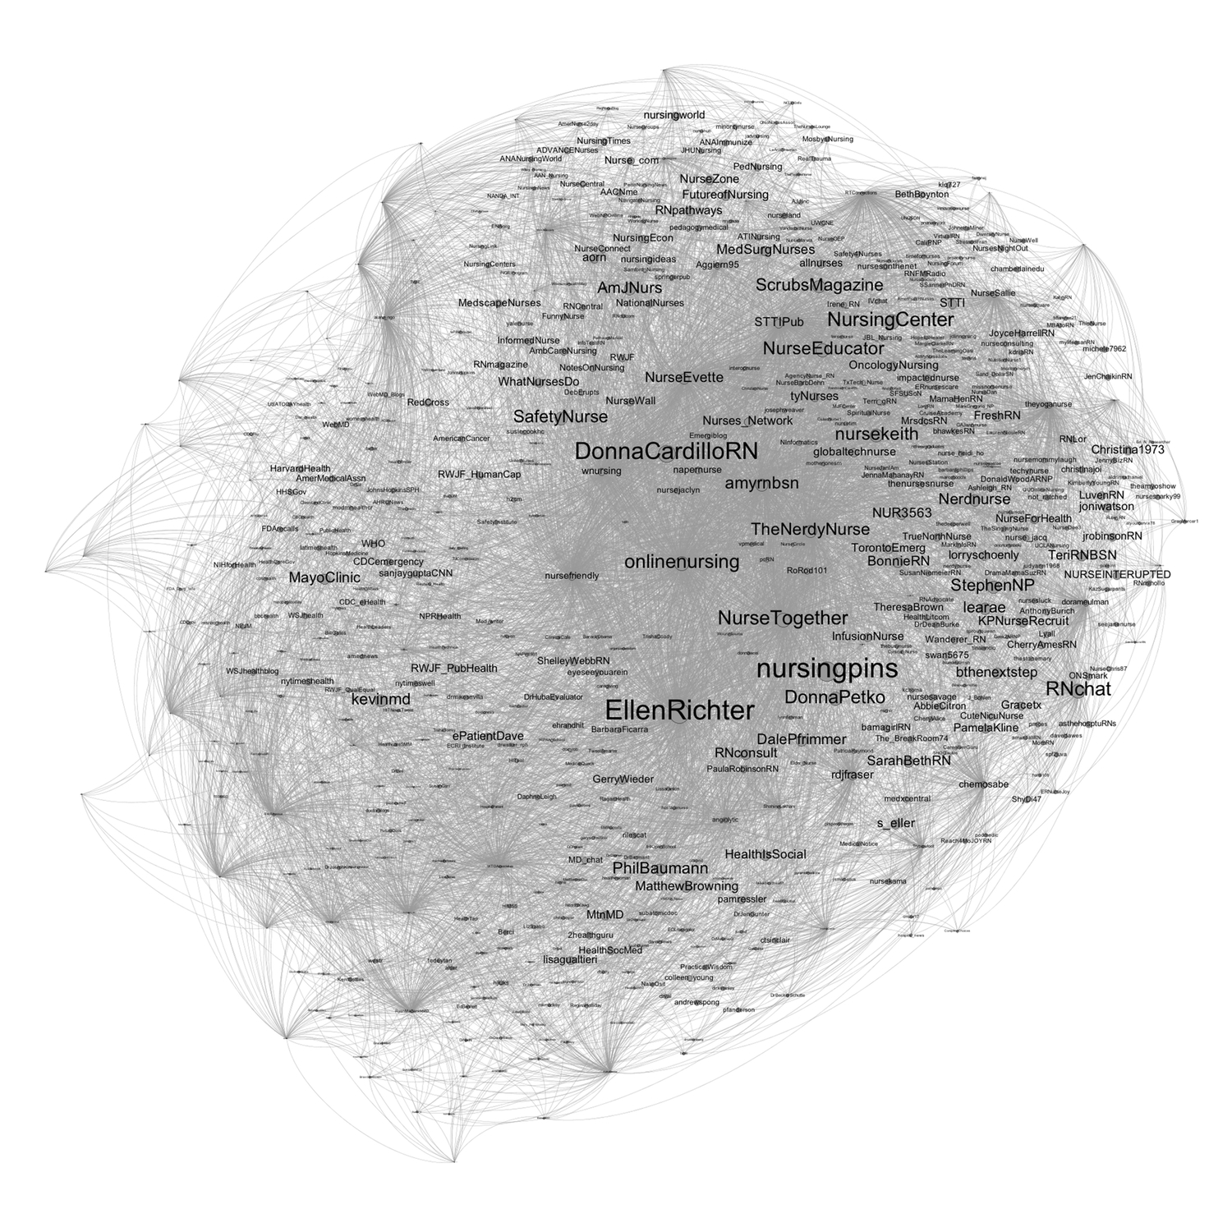
Original with more detail can be seen here: http://www.flickr.com/photos/psychemedia/7372864506/sizes/o/in/photostream/

Mention Mapp provides a similar service, although only allowing you to map the relationships of a single user at the moment. Entering LGIU, for example, allows you to find the users that account speaks with most, but also the hashtags that they use.

Finally, though a tool only for those with established followers, SocialBro gives you a quick dashboard overview of your followers and judges their influence on their follower numbers. While this is a quick and dirty way of assessing influence, it is nevertheless useful if time is short.

Facebook

Locating discussions on Facebook is slower but often that is because the discussions are happening either behind a locked group, or on users individual walls which you cannot see or join due to privacy settings. However there are a number of ways to still scan Facebook to find out what people are saying about your consultation, subject area, or policy. It is worth bearing in mind that when using a search engine, Facebook results rarely appear, and because of this reach of message should be considered.

Surface searches

Facebook doesn’t contain the same conversations as Twitter and a quick search for LGIU reveals this. LGIU do not have a presence on Facebook and this theme is common among ‘groups’ of stakeholders. However some organisations will have more luck than others. Department of Health will find tracking down health and medical groups far easier. A quick search on multiple sclerosis reveals the National Multiple Sclerosis Society on 140,000 +Likes and a very active engaged community. You will need to try and find a few key stakeholder groups to work out if you area of focus is well represented in this space or not.

Deeper information

There a number of tools which can trawl peoples unlocked walls for keyword searches. The first and most easy to use is http://48ers.com/ where I have demonstrated it’s use using the keywords “flooding” (if you have more than one word as a search term, always put between quote marks). At the time of writing this returns very few British results, but during times of flooding this is a rich resource.

In some cases this search will only be useful for monitoring and no engagement will be necessary, at others it will uncover hitherto hidden stakeholders. It will depend largely on your subject matter which it will be.

LinkedIN

LinkedIN has a similar search interface to Twitter. You can either do a simple search in the main toolbar at the top (you will need to be logged in, otherwise you will only be able to search by first name and surname which is no help with finding stakeholders) or you can click on the Advanced link to the right of the main search box. Searching by industries and groups will reap the best rewards, specifically groups. This is because whilst the majority of visible LinkedIN relates to employees and the companies who employ them, there is another layer beneath this which allows discussions of common interest between employees to flow. This is where you are likely to find topics under discussion which are of interest to you.

For example, enter Cabinet Office into the search and all those who identify as working for CO appear. David Cotterill is Deputy Director of Strategic Change, and the groups he is a member of start to appear in his entry as per below:

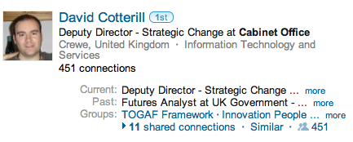
Click on more.... and you will be able to see all the groups he is a member of. If Innovation and Cloud Computing is your thing, chances are, that’s where the interesting conversations are happening. This means you are using David as your social curator - a trusted authoritative voice to lead you to where the good conversations are happening.

Forums

Forums are a mine of information and engaged and passionate people, and are generally open to all to read though posting usually requires an account. However, one of the trickiest things about web forums is that the creator of the forum decides if the posts show up in Google searches. Once you are aware of this, the lack of search results becomes clear and it is simple to see past this to the active and busy places forums actually are. Additionally, there are some tricks that you can use to delve a little deeper using Google Advanced Search which allows you to specify a site to search within. It does require you to know where the forums are which is a little simpler than might seem at first glance.

Take ex-pats as a community for example, a community we would possibly want to engage with quickly and easily.

Go to Google and search for expat forum. A number of different forums appear in the results list. A quick read through of each of them will give you a good idea of frequency of posting, the kinds of subjects being discussed and whether the country you’re interested in is represented. In some ways forums are the easiest to find but the most difficult to monitor and engage with, however it is worth investing the time as often the maturity and persistence of discussions can give high return.

Summary
Mapping your digital stakeholders across common digital engagement spaces requires time invested. Once you have invested that time, however, reviews of your space will be needed bi-yearly or yearly at most. New tools will always pop up but using these tools as part of your job means you will be one of the first to know about those tools. Most importantly, once you have carried out this exercise, you can share your knowledge relatively easily with your colleagues, both inside your Department and across government, meaning the same research does not need to be carried out again and again.

The subtleties of when and how to engage with stakeholders in these spaces was not the remit of this document. Should you require assistance with this, please speak to your organisation's digital teams.

